DAY 3 -AGILE AND SCRUM-FOUNDATIONS & BACKLOG WORKSHOP

SET 1 – ONLINE GROCERY DELIVERY APPLICATION

Question 1: Create a product vision for the Online Grocery Delivery Application and explain the three Scrum accountabilities with one anti-pattern for each.

For customers in the supermarket’s service area who want a convenient way to buy everyday groceries, the Online Grocery Delivery Application is a digital shopping platform that allows customers to browse and search products, manage a shopping cart, place and pay for orders, and track home delivery. It provides a simple, reliable way to shop without needing to visit the supermarket in person.

The three Scrum accountabilities and one anti-pattern for each
Scrum accountability | Main responsibility | Example anti-pattern
Product Owner | Maximizes product value; communicates the Product Goal and orders the Product Backlog. | Stakeholders bypass the Product Owner and give Developers conflicting priorities directly.
Scrum Master | Establishes Scrum, coaches the team and organization, and helps remove impediments. | Acts as a traditional project manager who assigns every task and controls how Developers work.
Developers | Create a usable Increment each Sprint and plan/manage the work needed to meet the Definition of Done. | Work in silos, wait for task assignment, or skip testing and quality checks to finish faster.

The three accountabilities work together: the Product Owner focuses on value, the Scrum Master supports effective Scrum, and Developers build a usable product Increment.

Question 2: Create epics and break them down into suitable user stories in Jira.
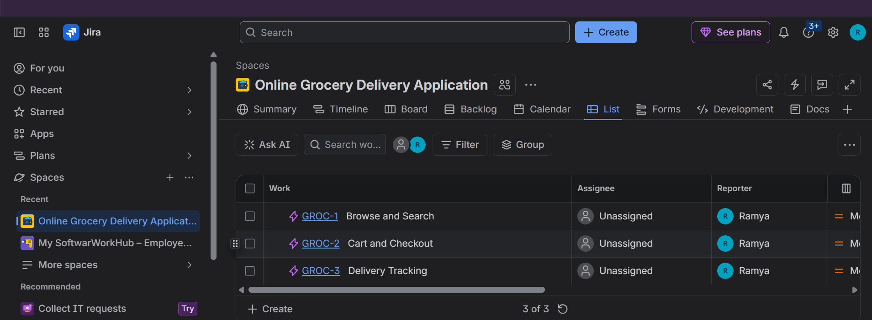
Screenshot 1. Jira List view showing the three epics.
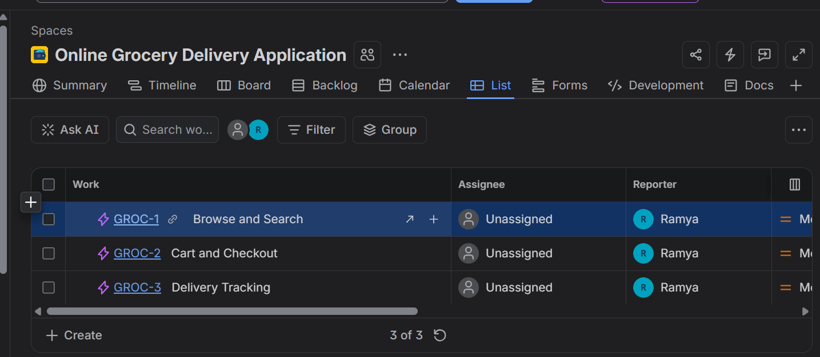
Screenshot 2. Jira work items created under the project.

Question 3: Review the user stories using the INVEST checklist and split any story that is too large.
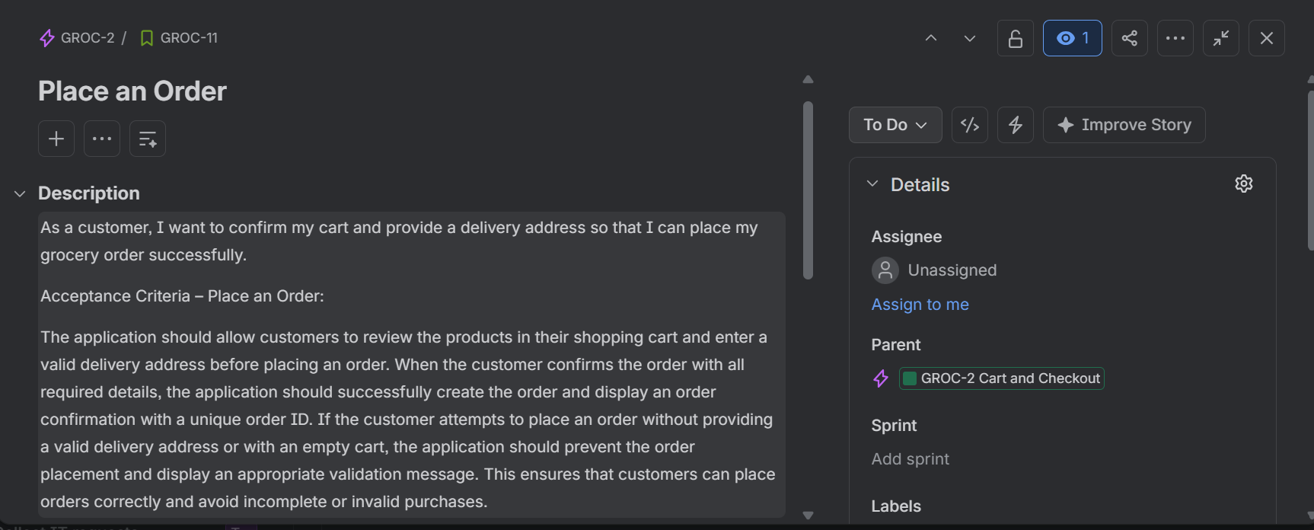
Screenshot 3. Refined Place an Order story.
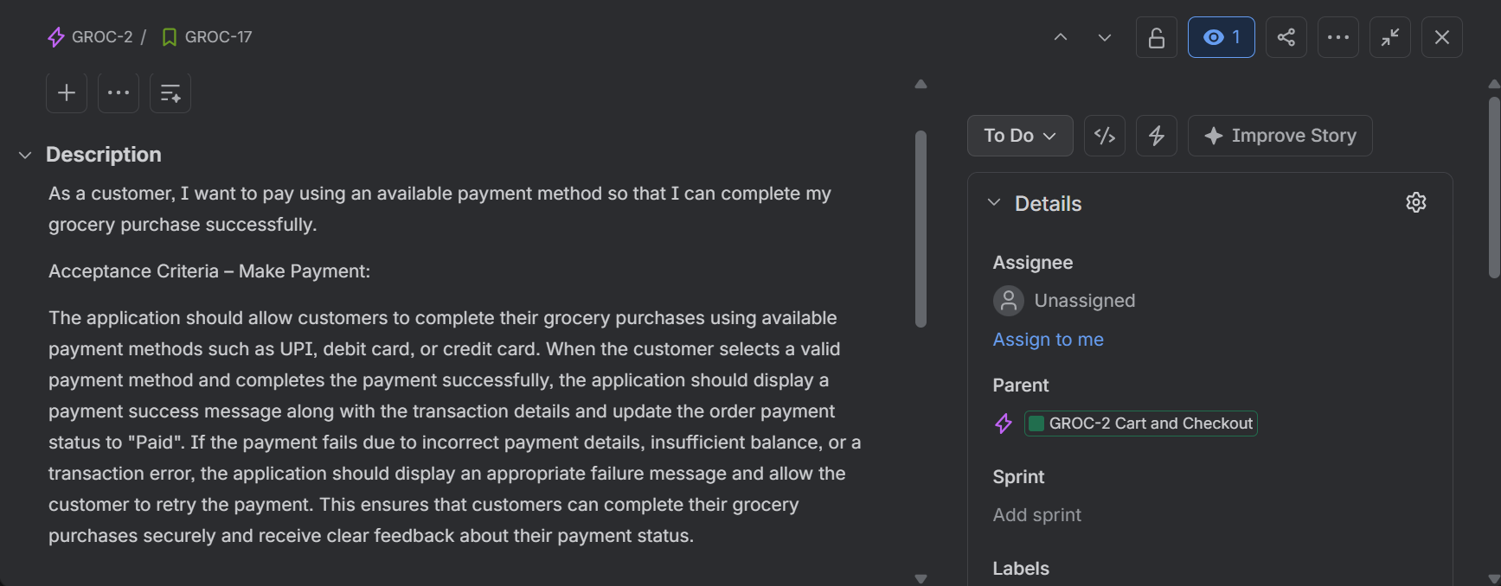
Screenshot 4. Separate Make Payment story.

Question 4: Write acceptance criteria for the user stories using Given, When and Then, including positive and negative scenarios.
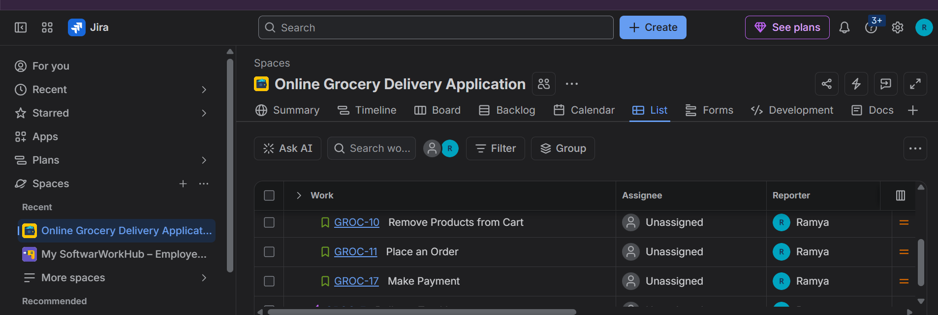
Screenshot 5. Search for Groceries – acceptance criteria.
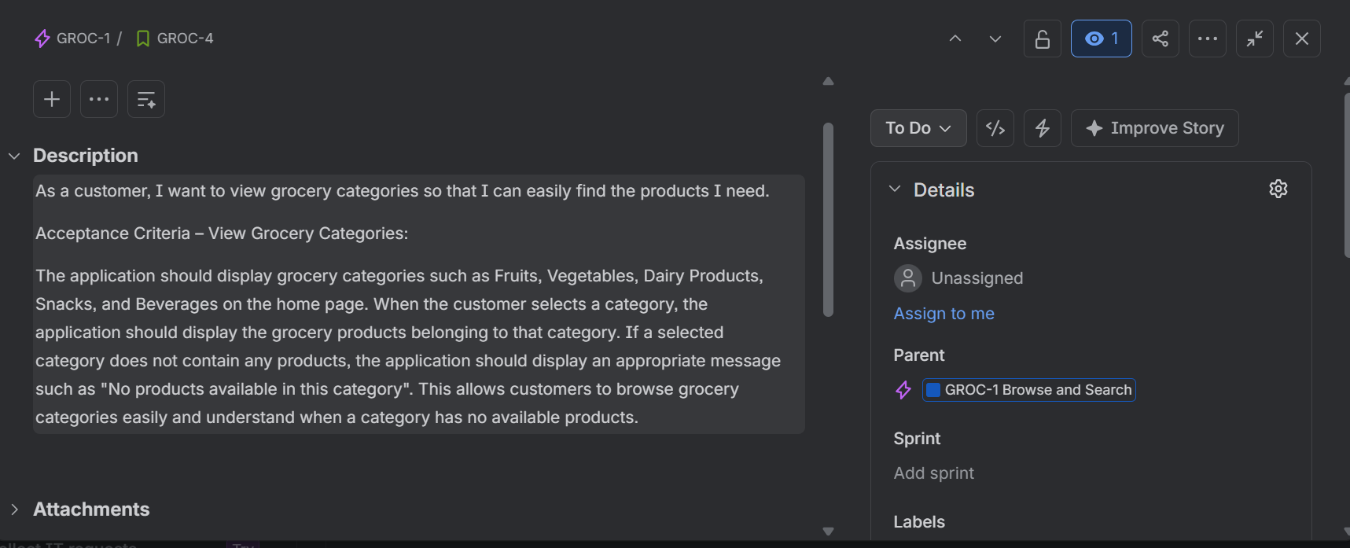
Screenshot 6. View Grocery Categories – acceptance criteria.
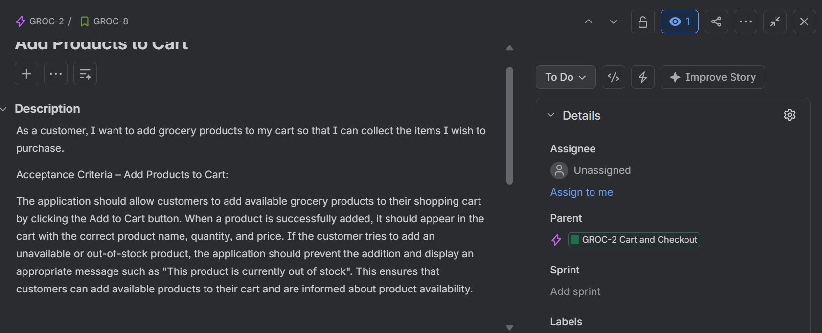
Screenshot 7. Add Products to Cart – acceptance criteria.
Screenshot 8. Place an Order – acceptance criteria.
Screenshot 9. Make Payment – acceptance criteria.

Question 5: Prioritize the user stories using MoSCoW and estimate their effort using Fibonacci story points. Select a reference story and justify the estimate.
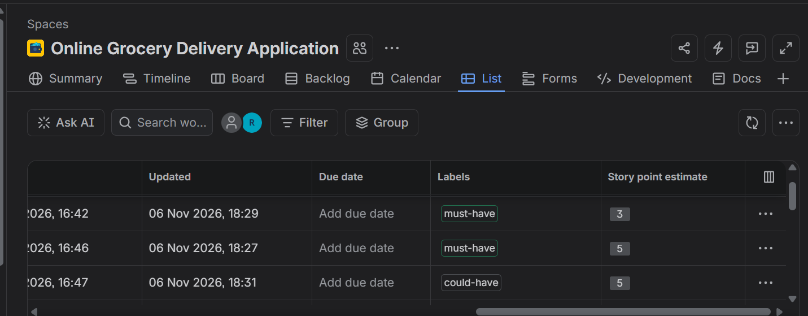
Screenshot 10. Jira List view showing story labels and story point estimates.
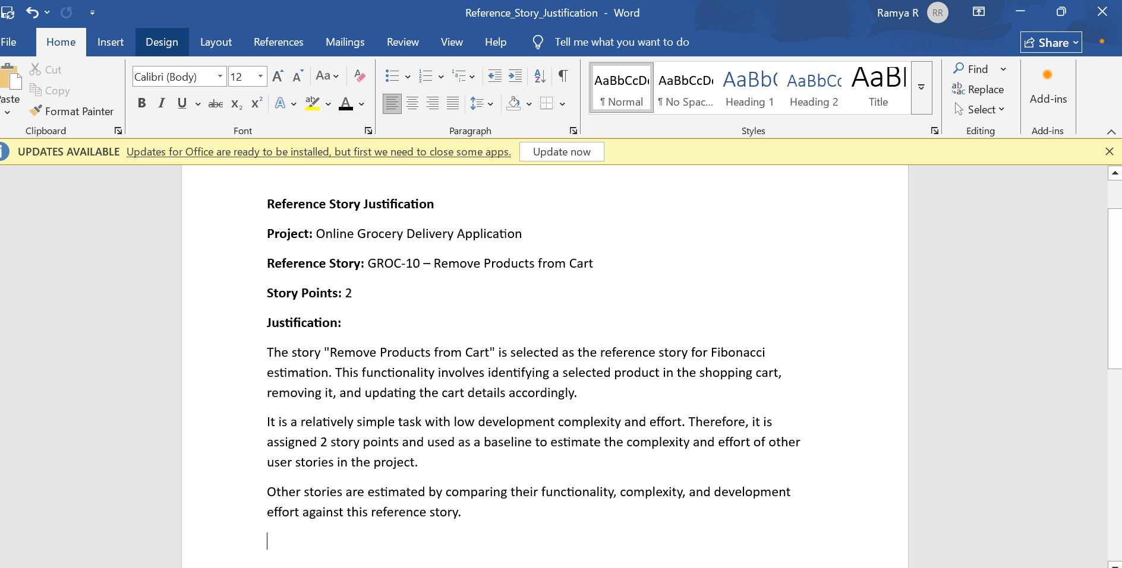
Screenshot 11. Reference story justification.

Question 6: Define the Definition of Ready (DoR) and Definition of Done (DoD) for the project.
The epics and their stories were created in the Online Grocery Delivery Application Jira space. Jira List and Backlog views were used to organize and review the work items. MoSCoW labels and story point estimates were added to the stories. The sprint remains unstarted until the team selects and commits to the sprint work. Jira backlog evidence is included in Sections 2 and 5.
Definition of Ready (DoR)
A user story is ready to be considered for a Sprint when:
It is written in the As a / I want / So that format.
The requirement and expected customer value are understandable.
Acceptance criteria are documented and testable.
Positive, negative and validation scenarios are identified where relevant.
The story has been reviewed against INVEST and is small enough to complete.
Dependencies, assumptions and required resources are identified.
The story has a MoSCoW priority and an agreed story-point estimate.
Definition of Done (DoD)
A user story is done when:
All agreed development work is complete.
The implementation meets every acceptance criterion.
Code has been reviewed and follows the team’s coding standards.
Unit and relevant functional tests have passed.
No critical or major defects remain open.
The change is integrated successfully with the application.
Required documentation is updated.
The completed work meets the team’s quality standard and is accepted by the Product Owner or responsible stakeholder.

Conclusion
The Online Grocery Delivery Application backlog has been structured into three epics and thirteen user stories. The stories were reviewed using INVEST, five stories were given positive and negative Given / When / Then scenarios, and MoSCoW labels and Fibonacci estimates were recorded. The reference-story rationale and the team’s Definition of Ready and Definition of Done are included in this submission.
.

SET 2 – INSURANCE CLAIMS PORTAL

Q1. Product Vision and Waterfall vs Agile

Product Vision
The Insurance Claims Portal aims to provide customers with a simple, secure and transparent platform to register insurance claims, upload supporting documents, track claim progress and receive approval, rejection and settlement notifications. It will reduce manual work, improve communication and support efficient claim processing.

Waterfall vs Agile – Key Differences
Aspect | Waterfall | Agile
Process | Sequential phases. | Short, iterative sprints.
Requirements | Defined mainly at the beginning. | Can be refined continuously.
Testing | Often performed after development. | Performed throughout development.
Changes | Can be costly to accommodate late. | Can be incorporated through backlog refinement.
Feedback | Usually at major milestones. | Frequent feedback and reviews.

Why Agile suits this portal
- Claim rules and customer needs may change; Agile supports continuous refinement.
- Features such as registration, document upload and tracking can be delivered incrementally.
- Regular reviews allow insurance stakeholders to give feedback early.
- Continuous testing helps identify validation and workflow issues sooner.

Q2. Create 4 Epics and 12–14 User Stories in Jira
Jira evidence – Insurance Claims Portal project, epics and user stories.

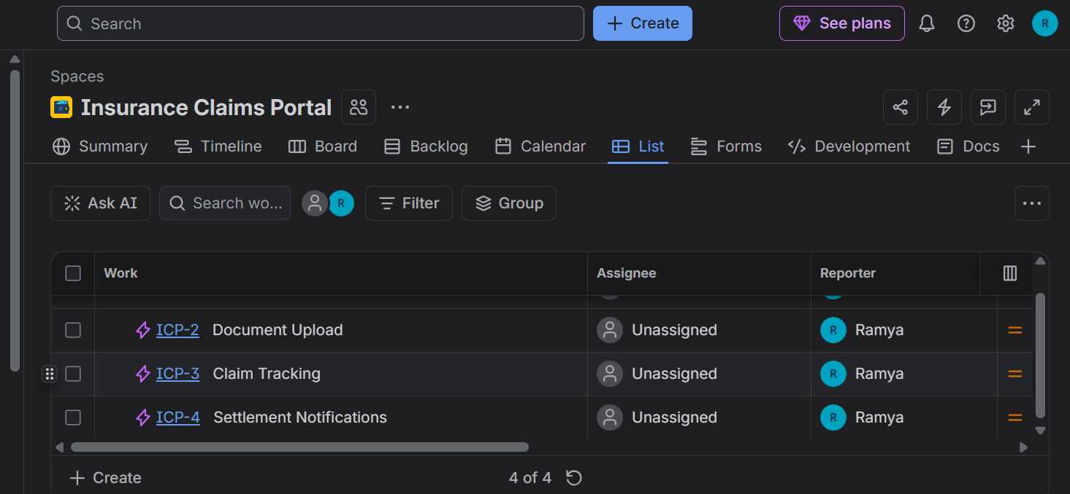
Jira project and epic/work-item list.
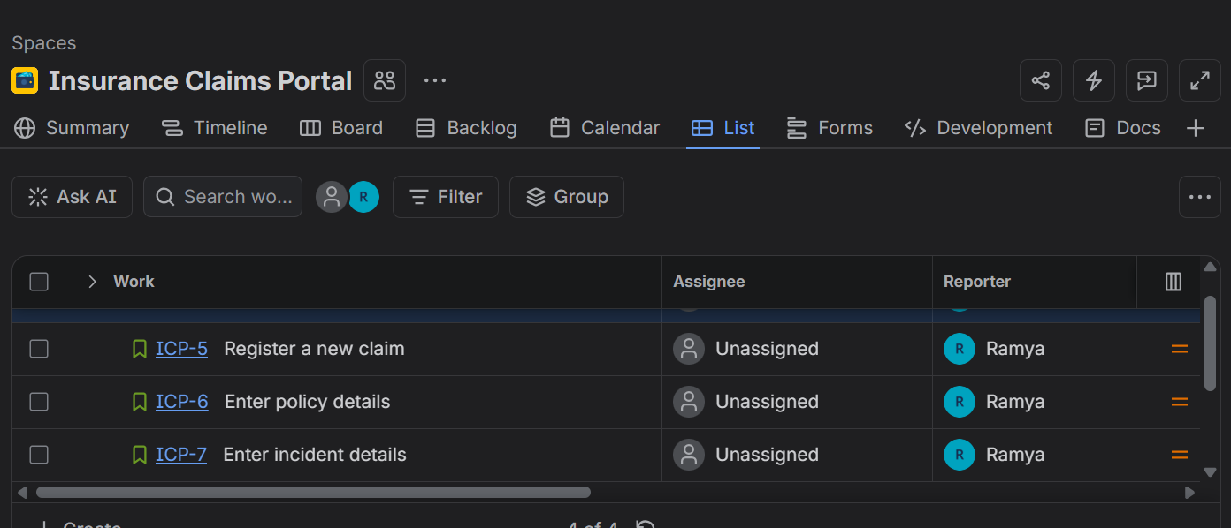
User stories in the Insurance Claims Portal.

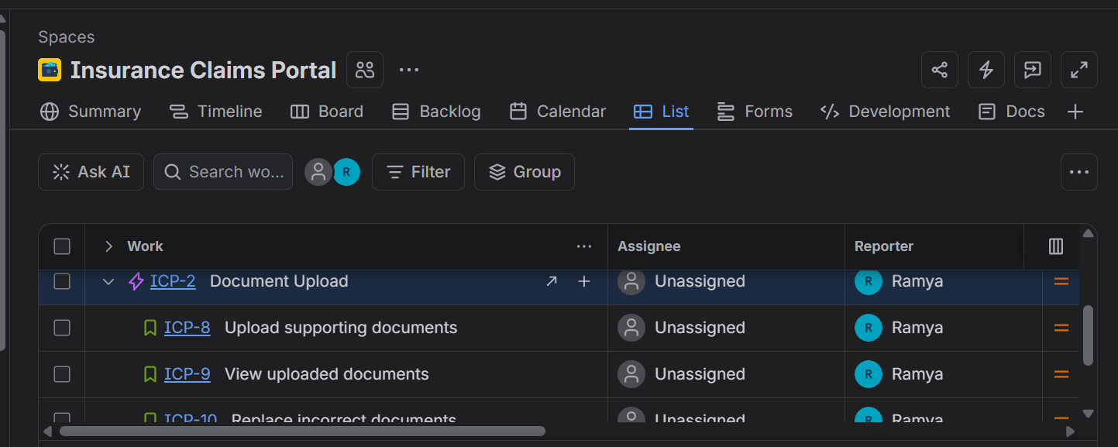
Additional user stories and their epic grouping.
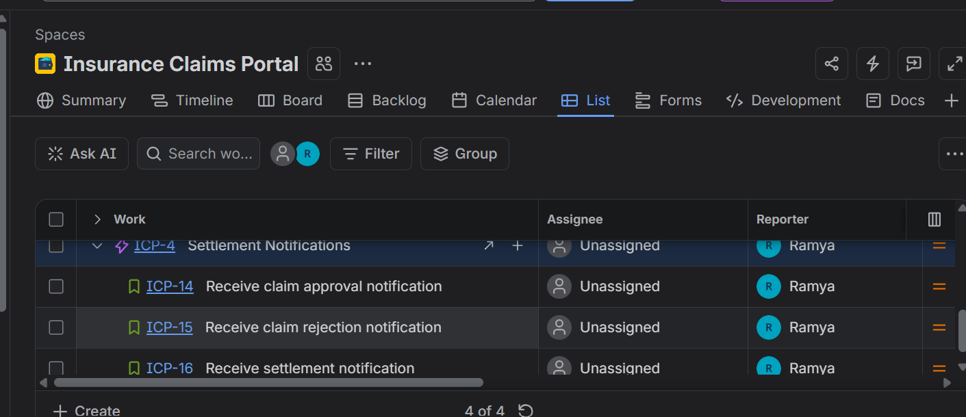
Remaining user stories, including settlement notification stories.

Q3. INVEST Review and Story Splitting
The 12 stories were reviewed against INVEST: Independent, Negotiable, Valuable, Estimable, Small and Testable. ICP-5 was refined to focus on submitting completed claim details and generating a claim ID, while ICP-6 and ICP-7 separately cover policy details and incident details. This removes overlap between the stories. The current stories are sufficiently focused; no additional split was required.
Jira story list used for the INVEST review.

Q4. Acceptance Criteria for Claim Registration Stories
Given–When–Then acceptance criteria, including positive and negative scenarios, were added to ICP-5, ICP-6 and ICP-7.
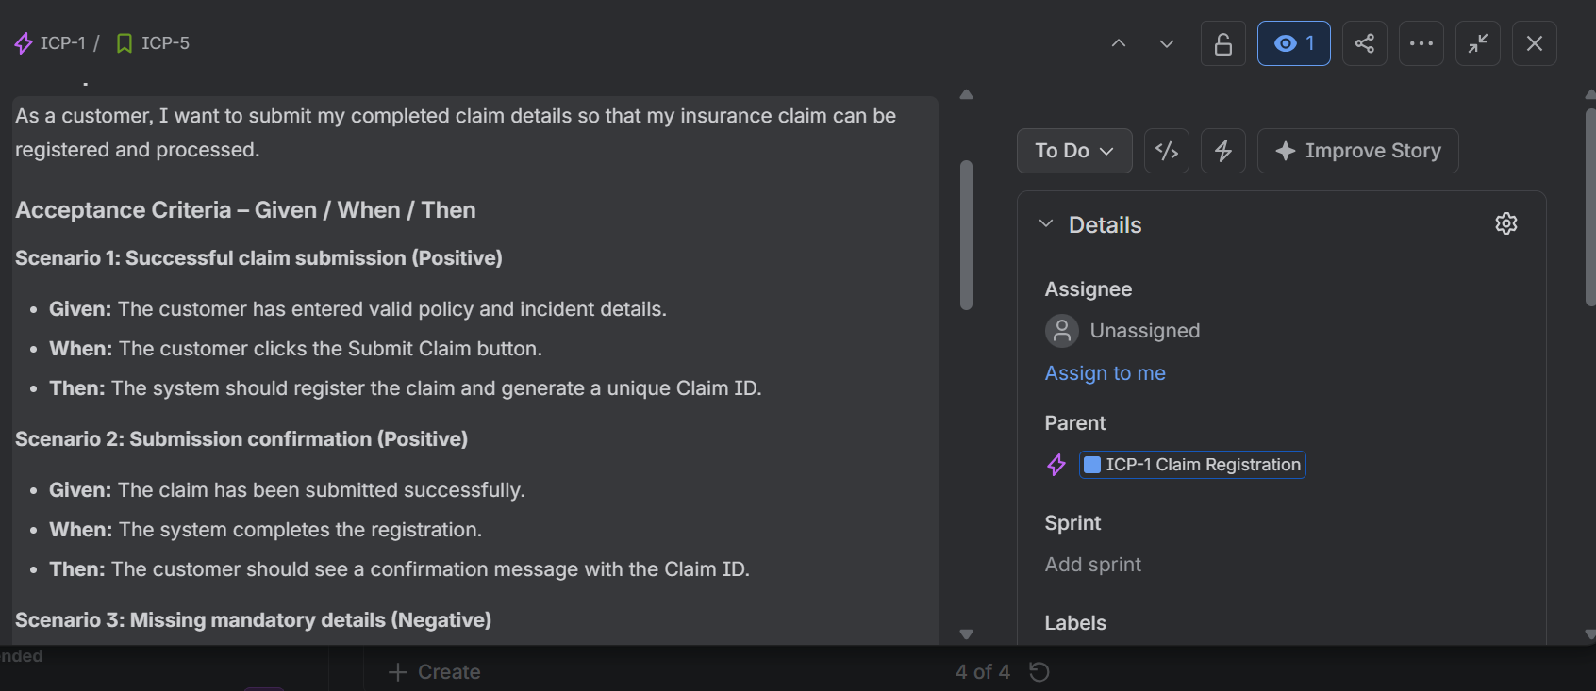
ICP-5 – Submit a Claim.
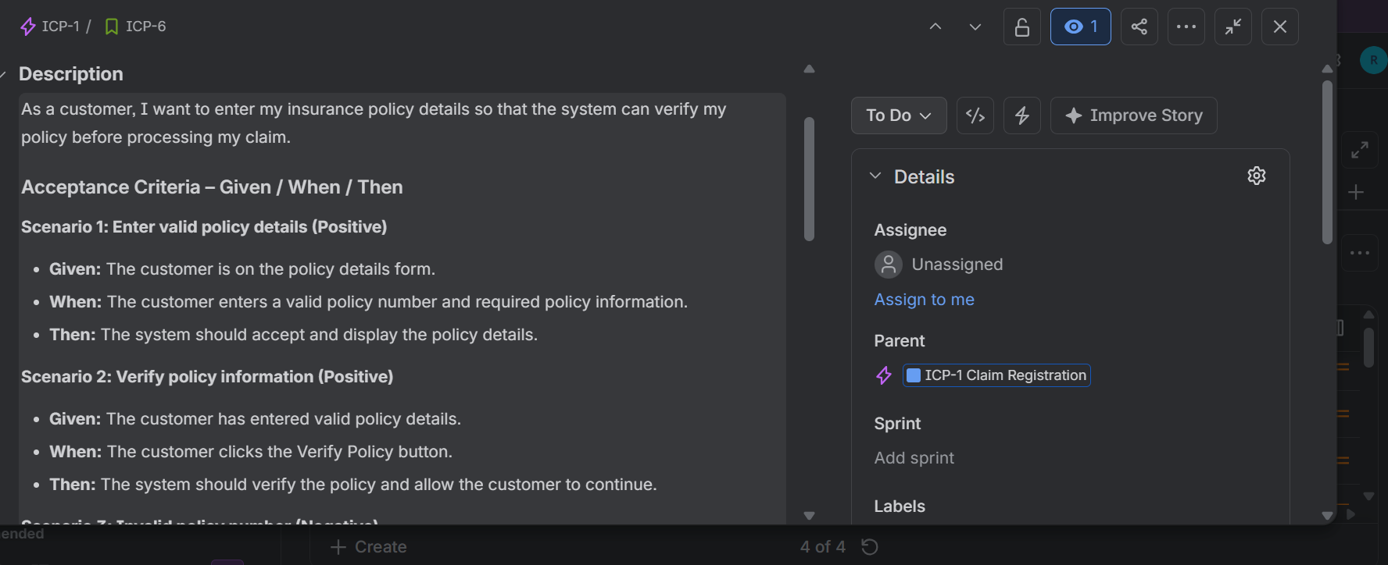
ICP-6 – Enter Policy Details.
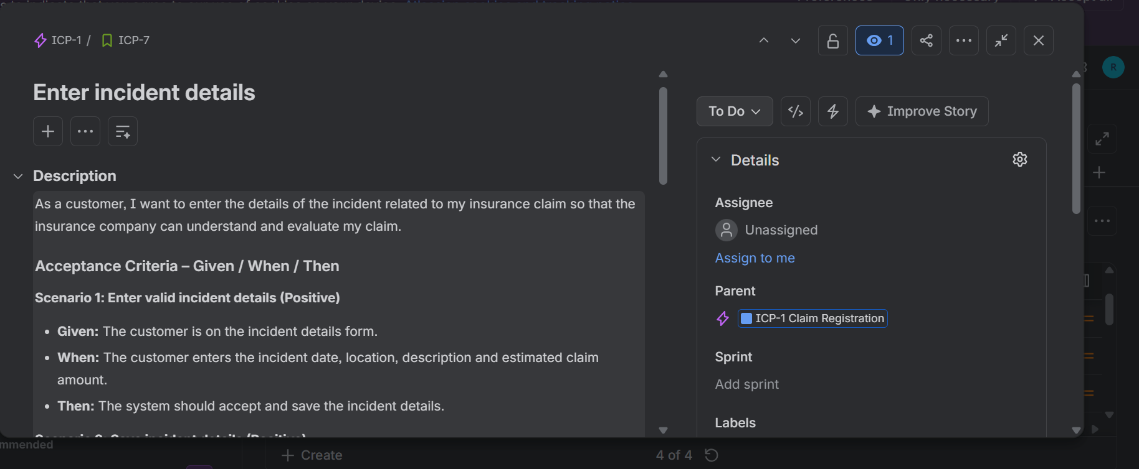
ICP-7 – Enter Incident Details.

Q5. Planning Poker and Fibonacci Estimation
The team estimates relative effort, complexity and uncertainty using Planning Poker. The Fibonacci scale used is 1, 2, 3, 5, 8 and 13.
Story ID | User Story | Points
ICP-5 | Submit a Claim | 3
ICP-6 | Enter Policy Details | 3
ICP-7 | Enter Incident Details | 3
ICP-8 | Upload Supporting Documents | 5
ICP-9 | View Uploaded Documents | 2
ICP-10 | Replace Incorrect Documents | 3
ICP-11 | View Claim Status | 2
ICP-12 | View Claim History | 3
ICP-13 | View Claim Details | 2
ICP-14 | Receive Claim Approval Notification | 3
ICP-15 | Receive Claim Rejection Notification | 3
ICP-16 | Receive Settlement Notification | 5
 | Total backlog estimate | 37

Planning Poker – Outlier Discussion
Story: ICP-8 – Upload Supporting Documents
- Developer 1 estimated 3 points for the basic upload function.
- Developer 2 estimated 5 points, considering file type and size validation.
- Tester estimated 8 points, considering upload failures and negative test cases.
- After discussing the additional validation and testing effort, the team agreed on 5 points.
Final agreed estimate for ICP-8: 5 points. Total backlog: 37 points.

6. Jira Board Workflow and Definition of Done
The Jira board was configured with four workflow statuses: To Do, In Progress, In Review and Done.
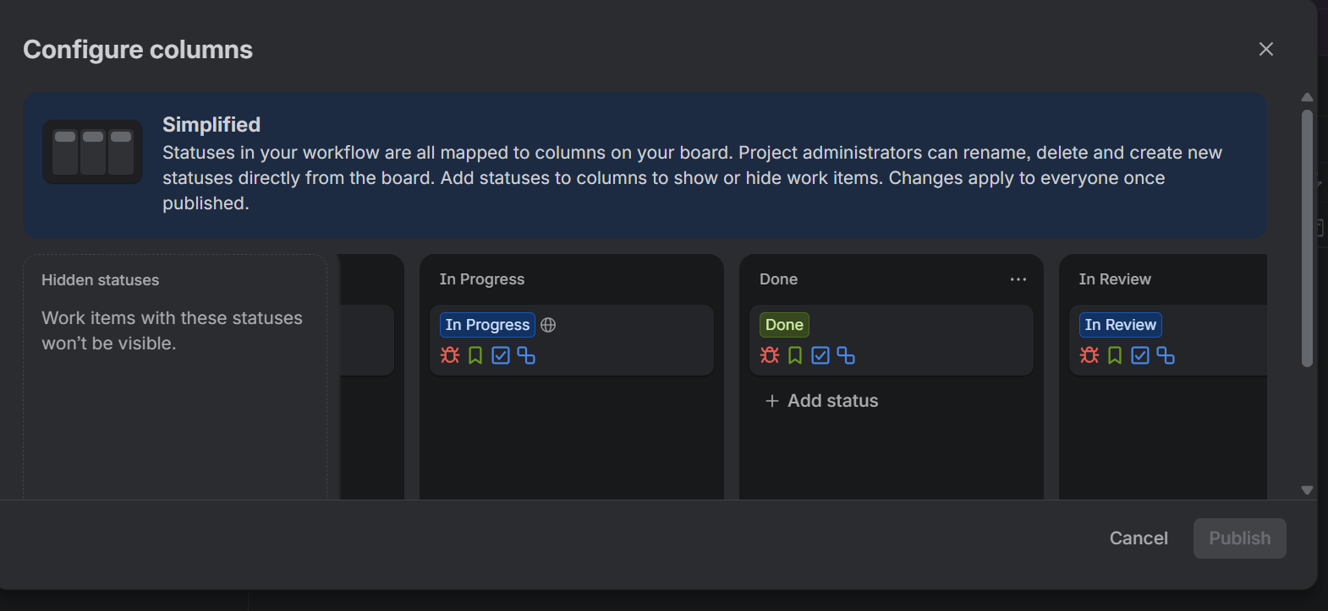
Jira workflow configuration showing the four statuses.

Definition of Done (DoD)
- All acceptance criteria are satisfied.
- Implementation is completed and code is reviewed.
- Unit and integration tests pass.
- No critical or major defects remain open.
- Relevant documentation is updated.
- The Product Owner accepts the completed story.

HOSPITAL APPOINTMENT BOOKING APPLICATION

Q1. Vision Statement and Stakeholder Mapping
Vision Statement
The Hospital Appointment Booking Application aims to provide patients with a convenient and user-friendly platform to book, reschedule and cancel doctor appointments. Patients can check doctor availability and receive appointment reminders, while hospitals can manage doctor schedules efficiently. The application will reduce manual work and waiting time, improve communication and increase patient satisfaction.
Stakeholder Mapping
Stakeholder | Mapped role | Responsibility
Hospital management / authorized product representative | Product Owner | Defines product goals, requirements and backlog priorities.
Scrum facilitator | Scrum Master | Facilitates Scrum events and helps remove blockers.
Development team | Developers | Designs, builds, tests and integrates the application.
Patients | Customer / end users | Search, book, reschedule and cancel appointments.
Doctors | Customer / end users | Set availability and view daily appointments.
Receptionists / hospital administrators | Stakeholders / end users | Support appointment operations and provide feedback.

Q2. Create 4 Epics and at Least 12 User Stories in Jira
The Hospital Appointment Booking Application Jira project contains four epics and twelve user stories, with three stories under each epic.
Epics and User Stories
HABA-1 – Appointment Booking
HABA-6 Search for Doctors; HABA-7 View Doctor Availability; HABA-8 Book an Appointment
HABA-2 – Rescheduling and Cancellation
HABA-9 Reschedule an Appointment; HABA-10 Cancel an Appointment; HABA-11 View Appointment Details
HABA-3 – Appointment Reminders
HABA-12 Receive Booking Confirmation; HABA-13 Receive Appointment Reminder; HABA-14 Receive Cancellation Notification
HABA-4 – Doctor Schedule Management
HABA-15 Set Doctor Availability; HABA-16 Update Doctor Schedule; HABA-17 View Daily Appointment Schedule
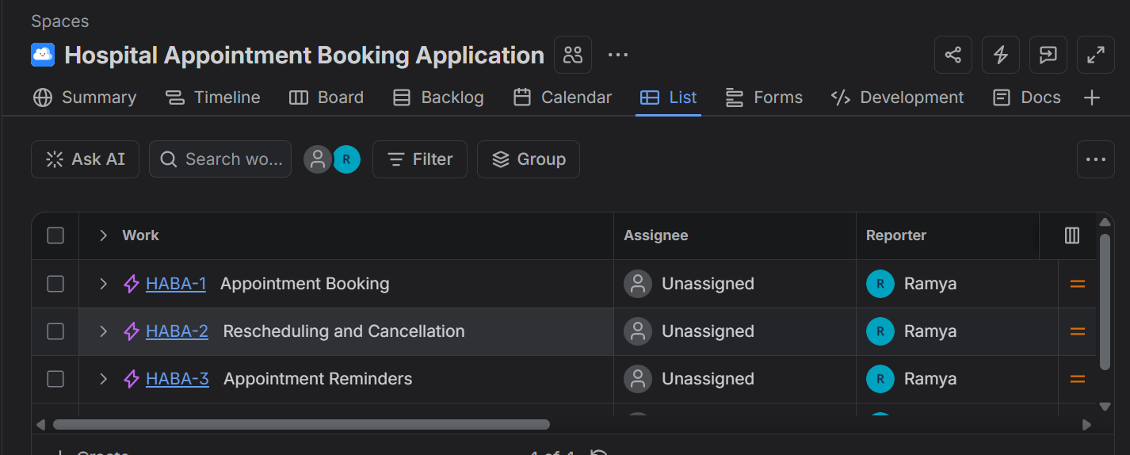
Jira project showing the epics created.
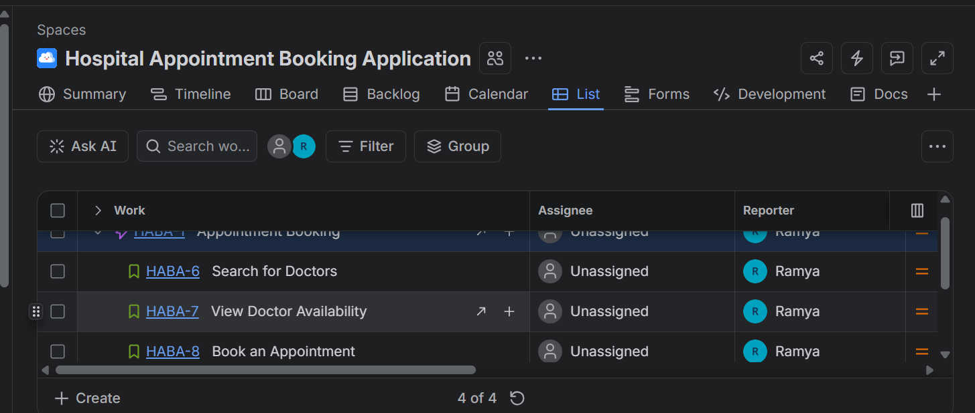
Jira list showing stories under the Appointment Booking epic.

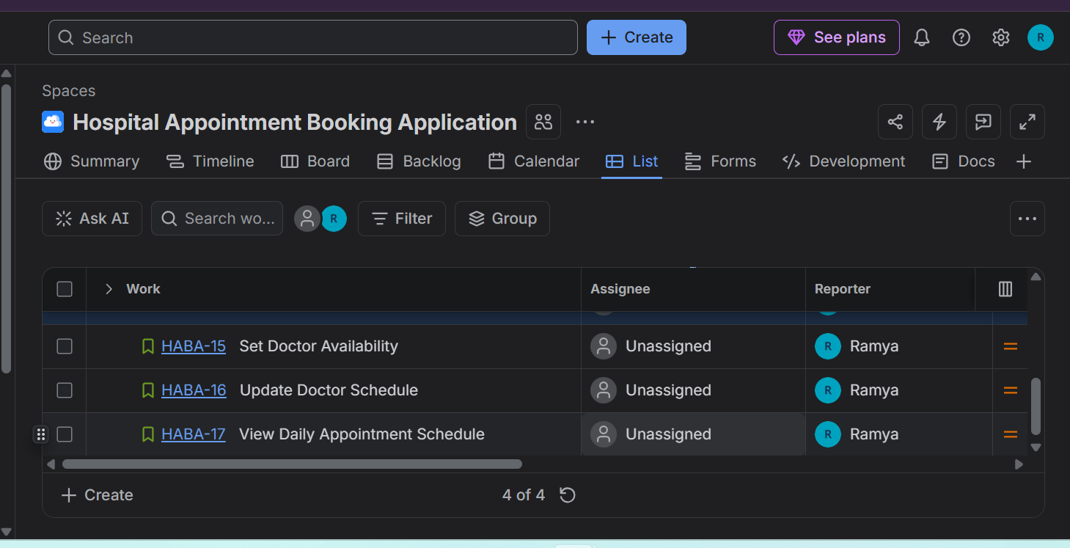
Jira list showing stories under Doctor Schedule Management.

Q3. INVEST Review and Story Improvements
The stories were reviewed using INVEST: Independent, Negotiable, Valuable, Estimable, Small and Testable. The review focused on whether each story can be understood, estimated, completed and verified independently.
Stories improved
HABA-8 – Book an Appointment: The acceptance criteria were improved to recheck slot availability at confirmation and reject a booking if another patient has already taken the slot. This prevents duplicate bookings.
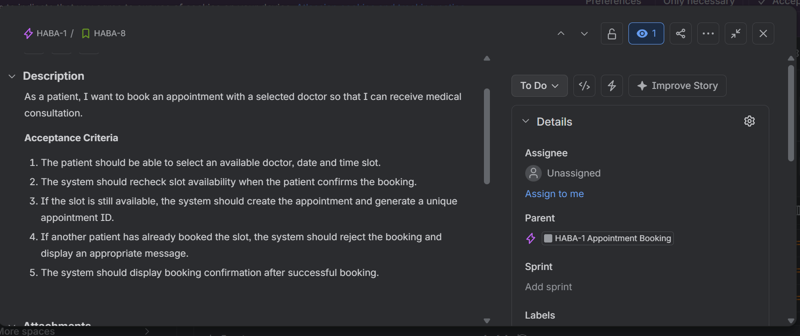
HABA-8 – refined booking criteria, including the already-booked slot condition.
HABA-16 – Update Doctor Schedule: The acceptance criteria were improved to check existing appointments before saving schedule changes and prevent conflicts with confirmed appointments.
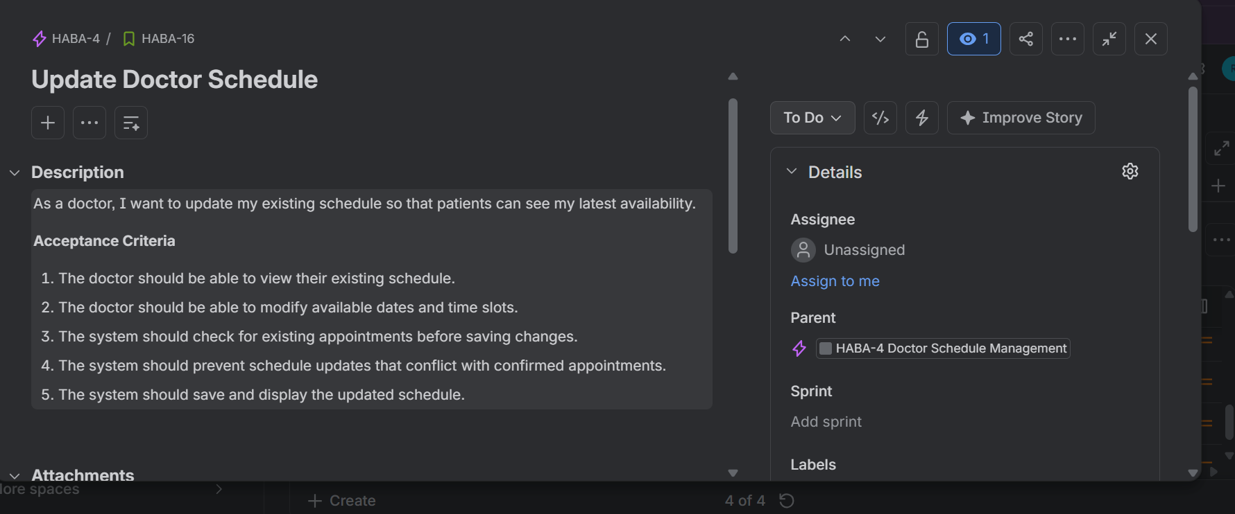
HABA-16 – refined schedule update criteria.
The remaining stories were considered sufficiently focused for this backlog. No additional stories were split; the backlog remains at twelve user stories.

Q4. Given / When / Then Acceptance Criteria
Detailed Given–When–Then acceptance criteria were added to the booking and cancellation stories. Positive and negative scenarios are included, especially the required already-taken slot case.
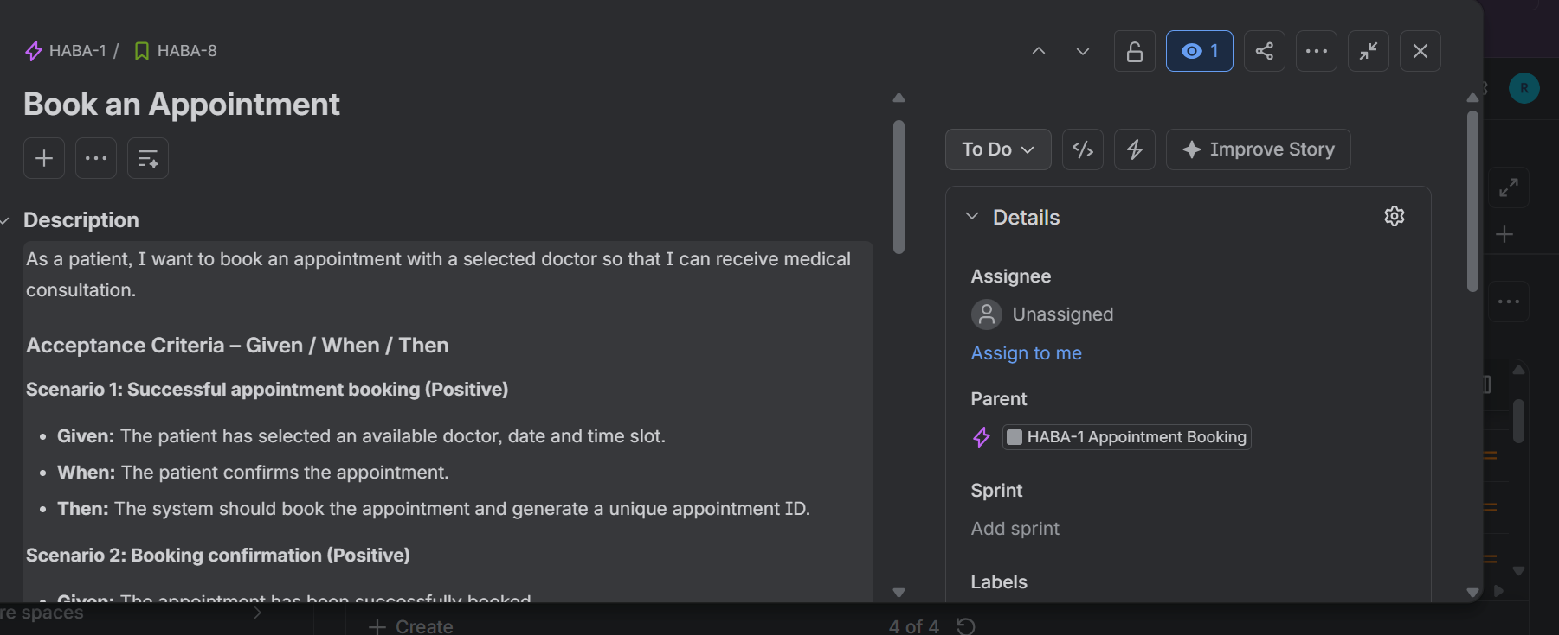
HABA-8 – Book an Appointment: booking scenarios, including an already-booked slot.
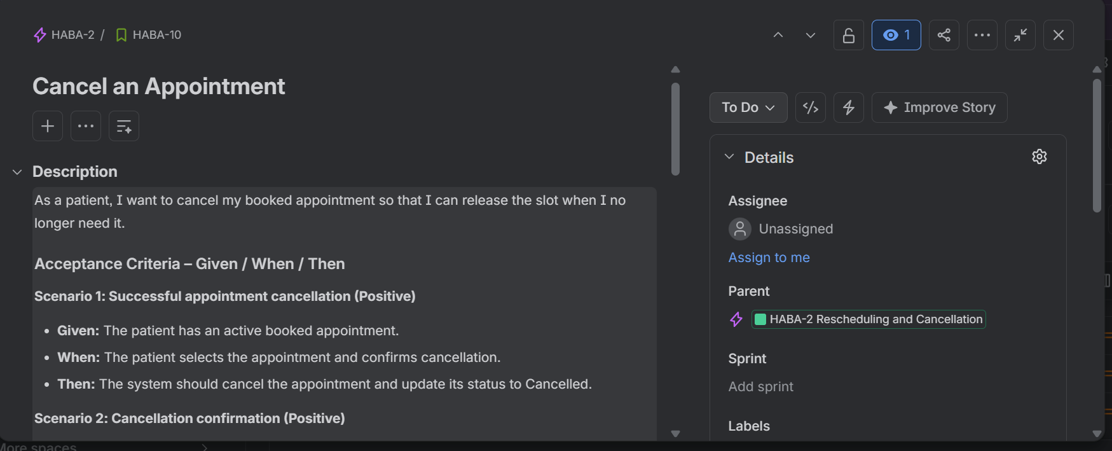
HABA-10 – Cancel an Appointment: cancellation scenarios.

Q5. Business Value, Effort and Planning Poker
Business value is rated from 1 (low) to 5 (very high). Priority reflects customer value and dependencies. Story points estimate relative effort, complexity and uncertainty; they are not hours.
Story ID | User Story | Business Value / Priority | Points
HABA-6 | Search for Doctors | 5 – Must | 3
HABA-7 | View Doctor Availability | 5 – Must | 2
HABA-8 | Book an Appointment | 5 – Must | 5
HABA-9 | Reschedule an Appointment | 4 – Must | 3
HABA-10 | Cancel an Appointment | 5 – Must | 2
HABA-11 | View Appointment Details | 3 – Should | 2
HABA-12 | Receive Booking Confirmation | 4 – Must | 1
HABA-13 | Receive Appointment Reminder | 4 – Should | 2
HABA-14 | Receive Cancellation Notification | 3 – Could | 1
HABA-15 | Set Doctor Availability | 5 – Must | 3
HABA-16 | Update Doctor Schedule | 4 – Should | 3
HABA-17 | View Daily Appointment Schedule | 4 – Should | 3
 | Total backlog estimate |  | 30
Planning Poker – Outlier Discussion
Story: HABA-8 – Book an Appointment
Developer 1 estimated 3 points because the basic booking flow appeared straightforward.
Developer 2 estimated 5 points because availability must be rechecked and a unique appointment ID generated.
Tester estimated 8 points because testing includes already-booked slots, duplicate booking attempts and error handling.
After discussion, the team agreed on 5 story points.
This is an illustrative Planning Poker discussion for the assignment, not a record of an actual team vote.
Story Points vs Hours
Story points represent relative effort, complexity and uncertainty. Hours represent time spent on work. Story points are not directly converted into hours because team members may complete the same work at different speeds.

Q6. Jira Backlog, Board, Definition of Ready and Definition of Done
The Jira project contains the four epics and twelve stories. The board workflow is configured with To Do, In Progress, In Review and Done statuses.
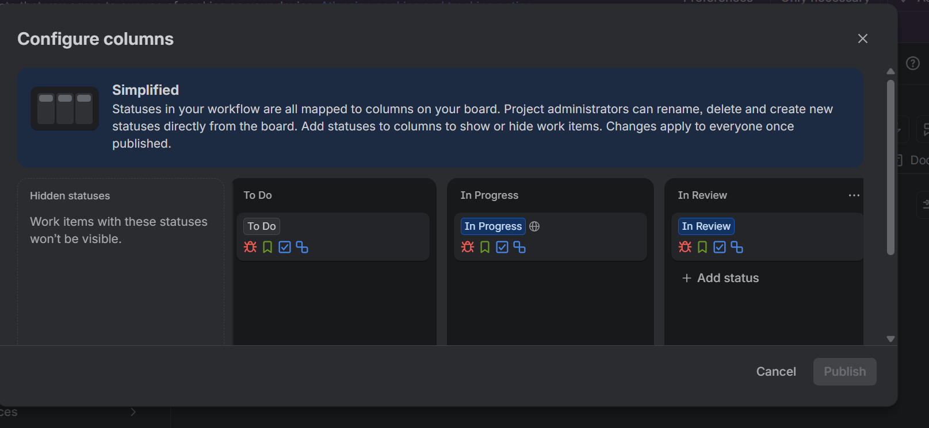
Jira Configure Columns view showing To Do, In Progress and In Review; the Done column is further to the right in the same configuration window.
Definition of Ready (DoR)
The user story is clearly written and understandable.
Acceptance criteria are defined and testable.
Business value and priority are identified.
Dependencies and assumptions are identified.
Required designs, data or reference materials are available.
The story is small enough to complete within a sprint.
The team understands the expected outcome.
The story can be estimated by the development team.
Definition of Done (DoD)
All acceptance criteria are satisfied.
Development is completed according to the agreed requirements.
Code review is completed and approved.
Unit and integration tests pass.
No critical or major defects remain open.
The feature is tested successfully in the application.
Relevant technical or user documentation is updated.
The Product Owner accepts the completed story.

